Computer vision homework 8

B04902028 資工三 洪浩翔

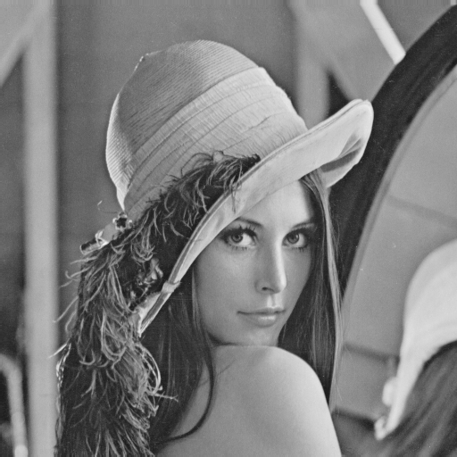

Original Lena image

1. Gaussian noise:

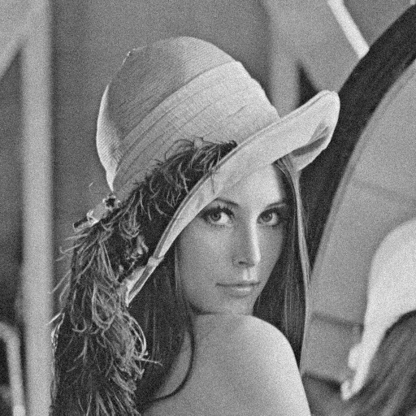 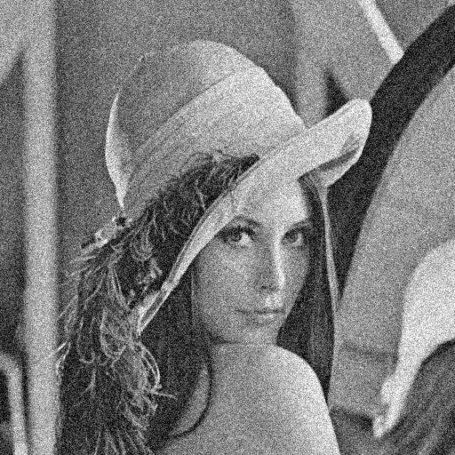

Amp = 10 Amp = 30

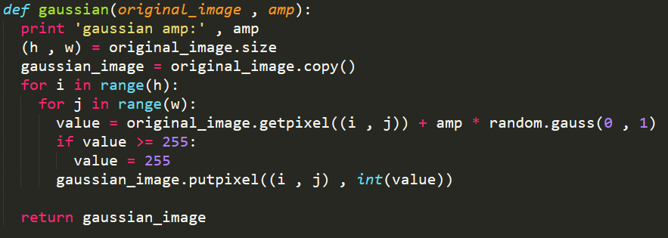

Code of Gaussian noise

2. Salt and pepper noise:

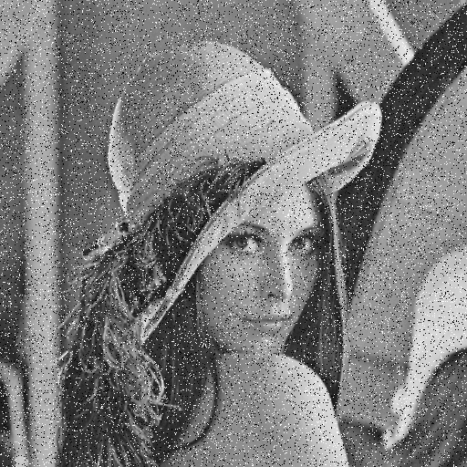 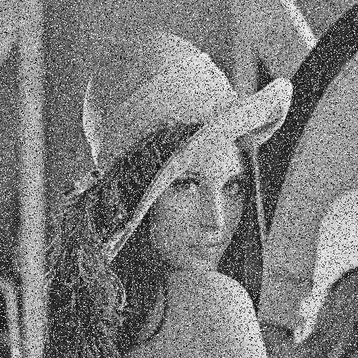

Threshold = 0.05 threshold = 0.1

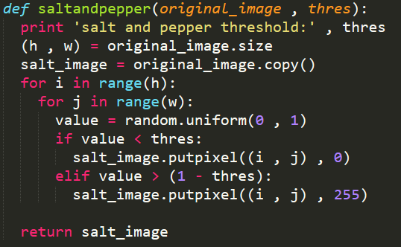

Code of salt and pepper noise

3. Box filter:

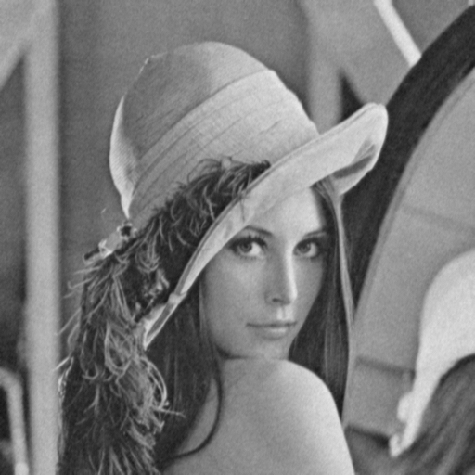 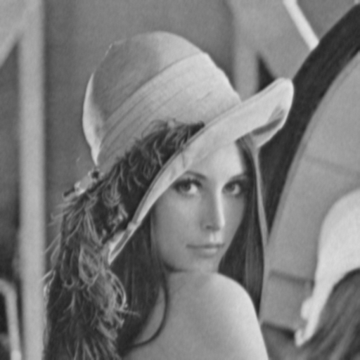

3x3 with Gaussian(amp = 10) 5x5 with Gaussian(amp = 10)

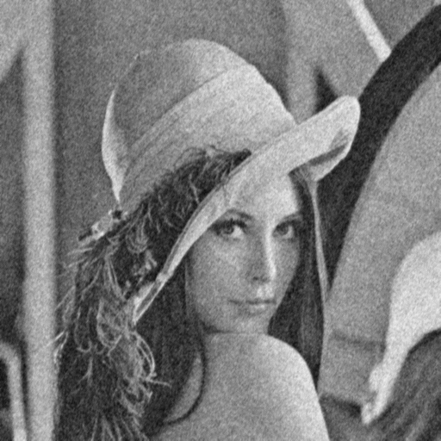 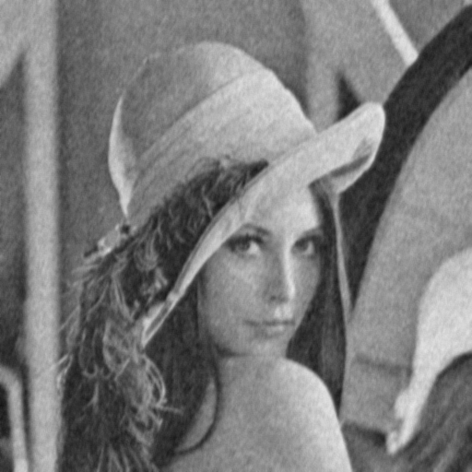

3x3 with Gaussian(amp = 30) 5x5 with Gaussian(amp = 30)

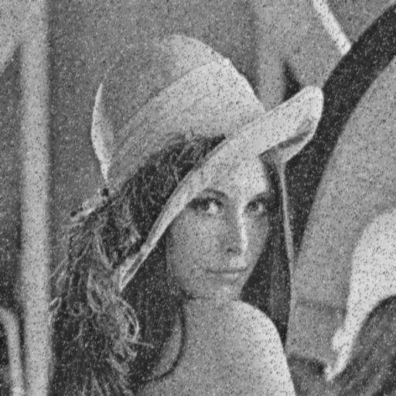 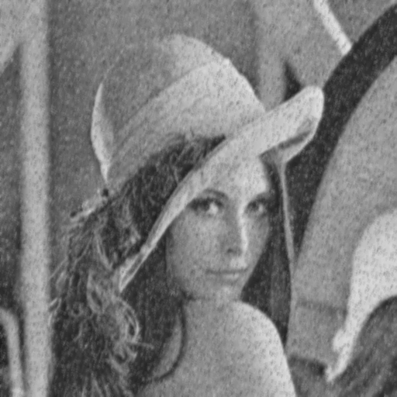

3x3 with salt(threshold = 0.05) 5x5 with salt(threshold = 0.05)

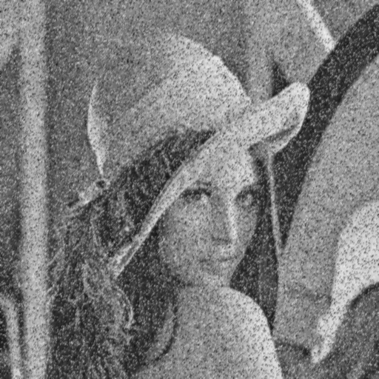 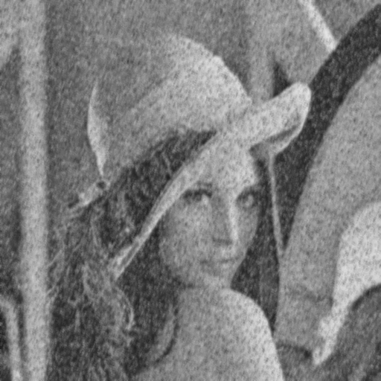

3x3 with salt(threshold = 0.1) 5x5 with salt(threshold = 0.1)

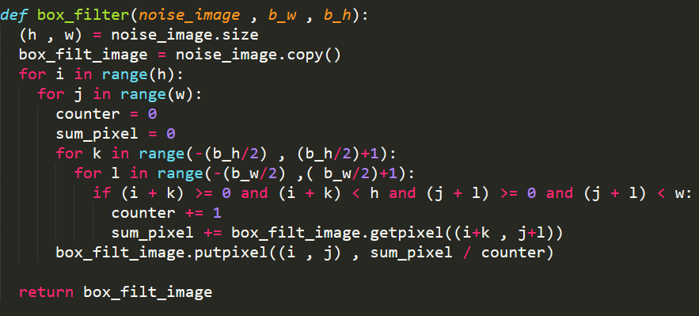

Code of box filter

4. Median filter:

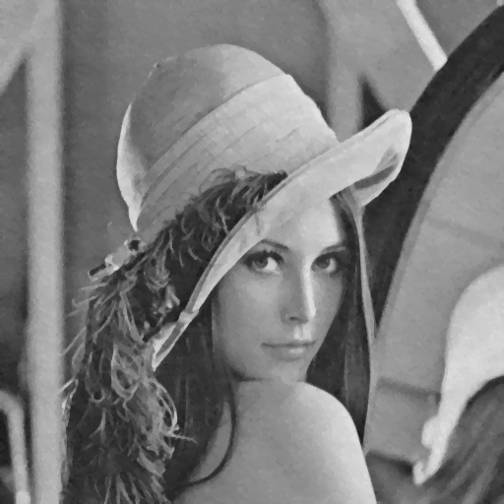 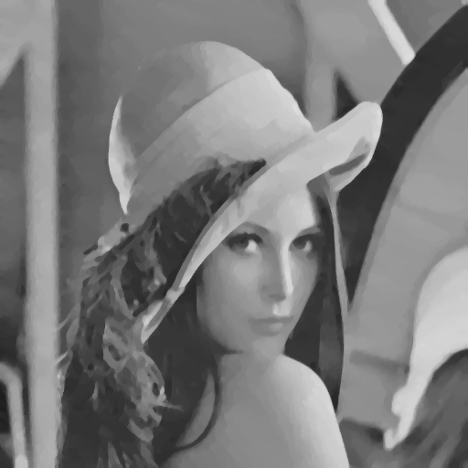

3x3 with Gaussian(amp = 10) 5x5 with Gaussian(amp = 10)

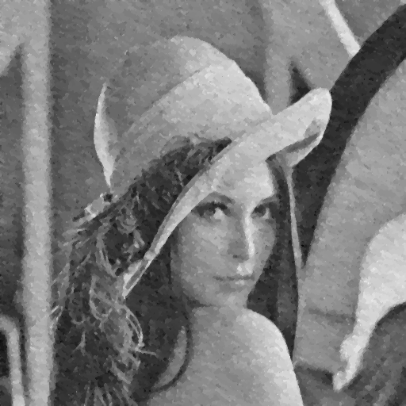 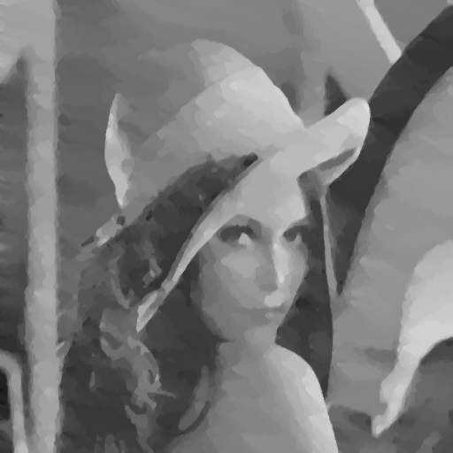

3x3 with Gaussian(amp = 30) 5x5 with Gaussian(amp = 30)

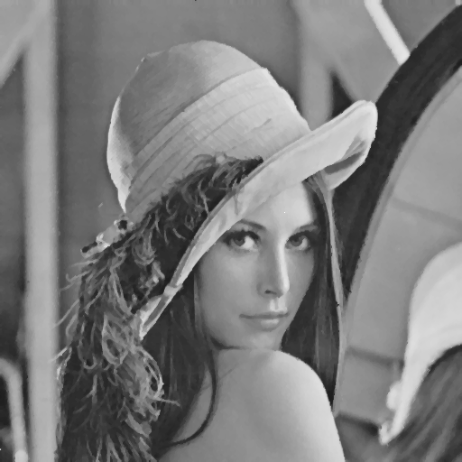 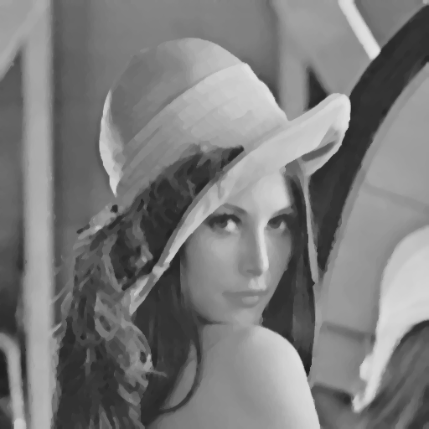

3x3 with salt(threshold = 0.05) 5x5 with salt(threshold = 0.05)

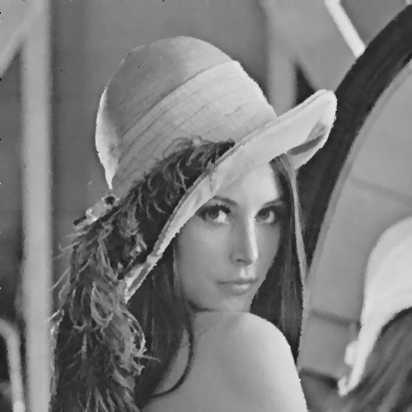 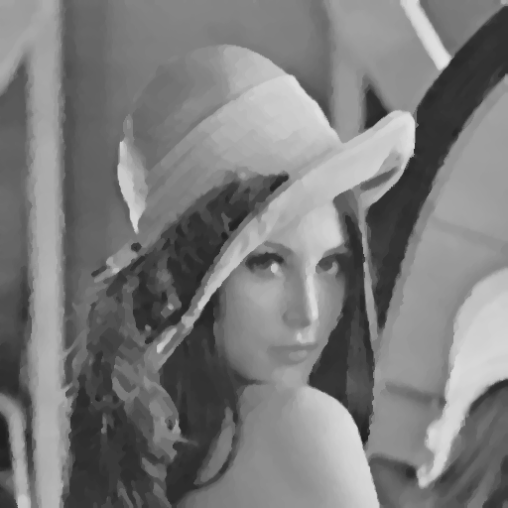

3x3 with salt(threshold = 0.1) 5x5 with salt(threshold = 0.1)

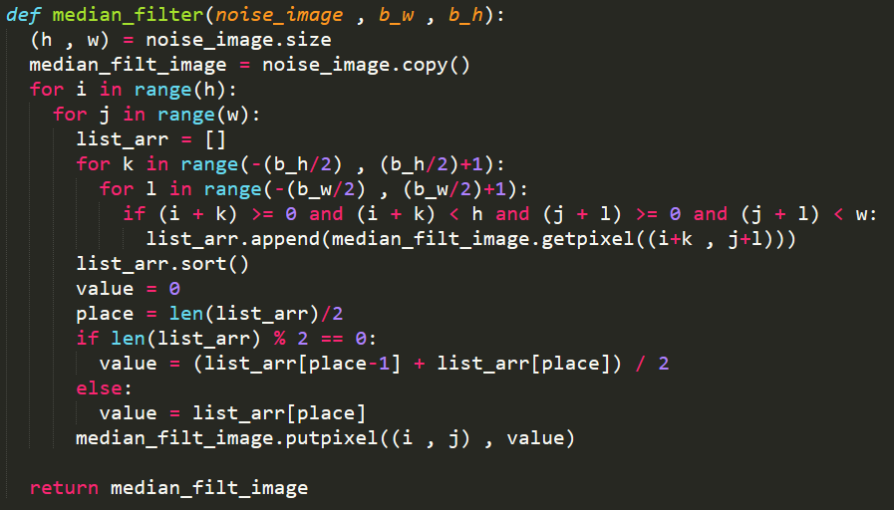

5. Opening then closing:

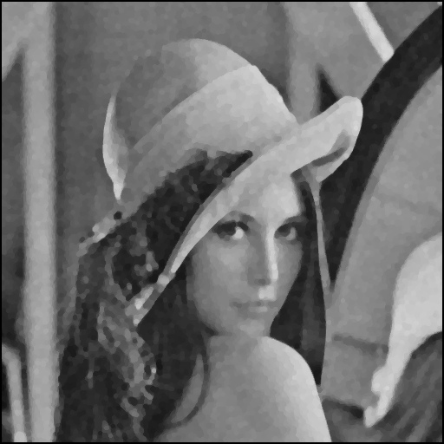 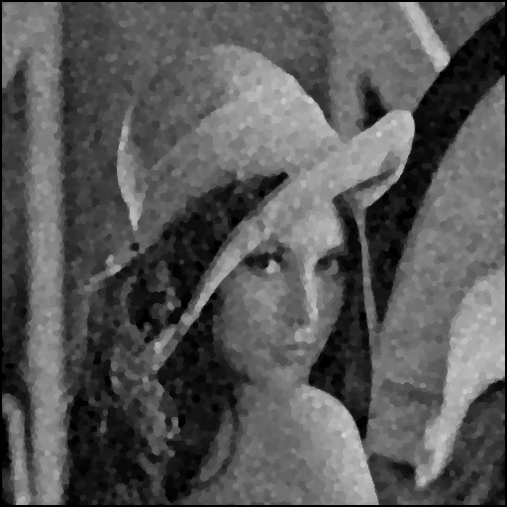

On Gaussian with amp = 10 On Gaussian with amp = 30

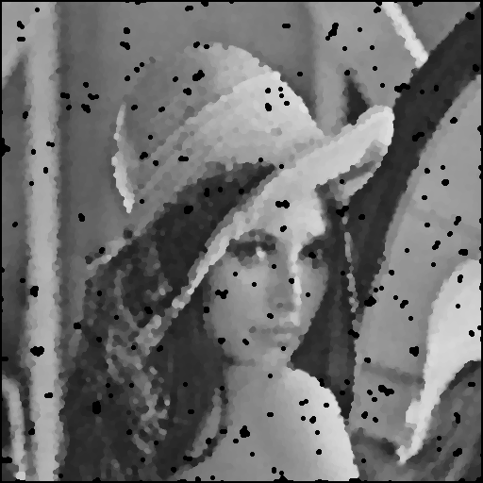 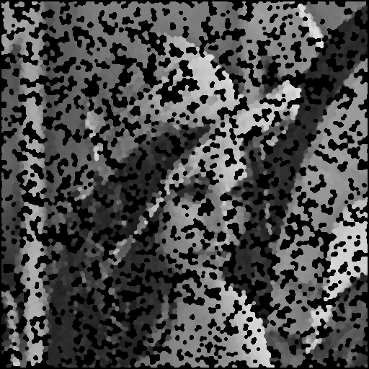

On salt with threshold = 0.05 On salt with threshold = 0.1

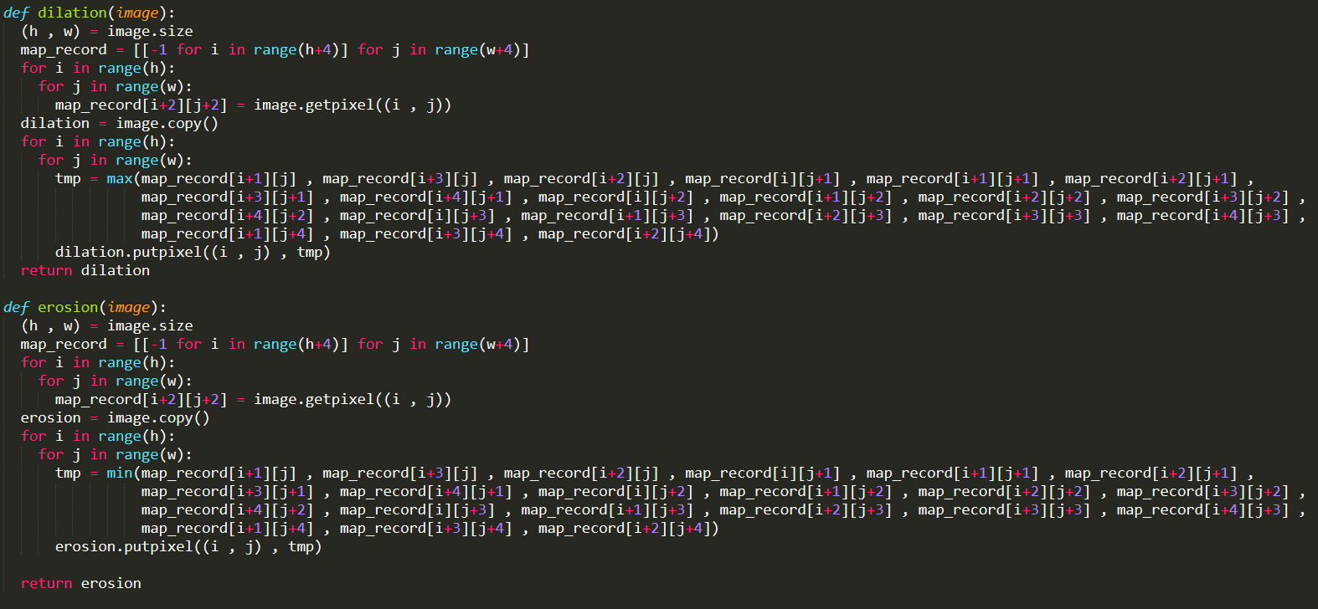

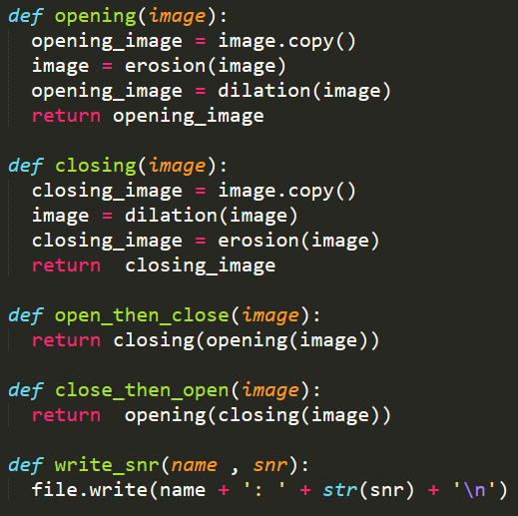

Code of opening then closing

6. Closing then opening:

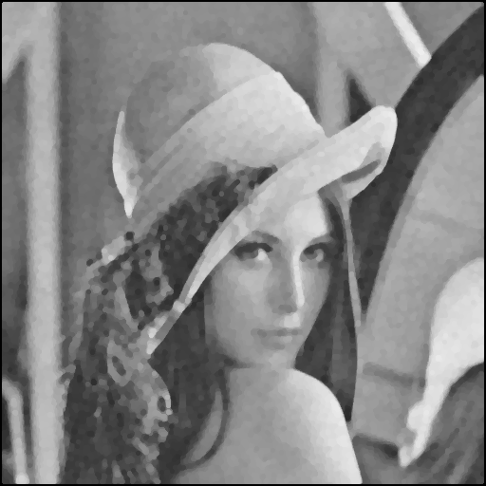 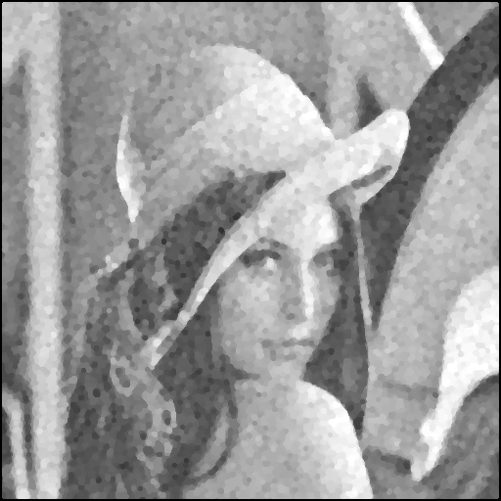

On Gaussian with amp = 10 On Gaussian with amp = 30

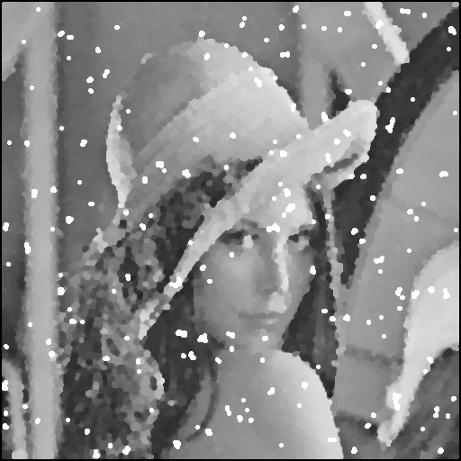 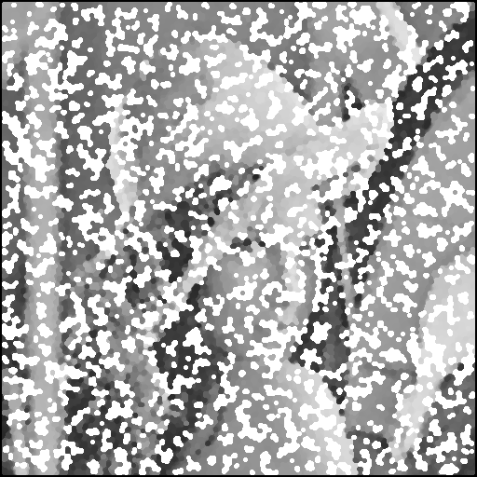

On salt with threshold = 0.05 On salt with threshold = 0.1



Code of closing then opening

7. SNR:

gaussian with apt = 10: 13.615062885

gaussian with apt = 30: 4.16345011273

salt-and-pepper with threshold = 0.1: -2.09480634806

salt-and-pepper with threshold = 0.5: 0.962335873449

box filter with gaussian(apt = 10) and 3 x 3: 17.7586211403

box filter with gaussian(apt = 30) and 3 x 3: 12.6005180655

box filter with gaussian(apt = 10) and 5 x 5: 14.872644709

box filter with gaussian(apt = 30) and 5 x 5: 13.2534778522

median filter with gaussian(apt = 10) and 3 x 3: 17.6998635713

median filter with gaussian(apt = 30) and 3 x 3: 11.0857180412

median filter with gaussian(apt = 10) and 5 x 5: 16.0127050249

median filter with gaussian(apt = 30) and 5 x 5: 12.8580945551

open then close with gaussian(apt = 10): 8.60681375489

open then close with gaussian(apt = 30): 8.63171025024

close then open with gaussian(apt = 10): 7.66090486363

close then open with gaussian(apt = 30): 6.05850931253

box filter with salt and pepper(threshold = 0.1) and 3 x 3: 6.36526871914

box filter with salt and pepper(threshold = 0.05) and 3 x 3: 9.51486144906

box filter with salt and pepper(threshold = 0.1) and 5 x 5: 8.55247615075

box filter with salt and pepper(threshold = 0.05) and 5 x 5: 11.1970926351

median filter with salt and pepper(threshold = 0.1) and 3 x 3: 15.1114750513

median filter with salt and pepper(threshold = 0.05) and 3 x 3: 19.1410327818

median filter with salt and pepper(threshold = 0.1) and 5 x 5: 15.7804135126

median filter with salt and pepper(threshold = 0.05) and 5 x 5: 16.3911094286

open then close with salt and pepper(threshold = 0.1): -2.23485612528

open then close with salt and pepper(threshold = 0.05): 4.41100712156

close then open with salt and pepper(threshold = 0.1): -2.87604166466

close then open with salt and pepper(threshold = 0.05): 4.12927427708

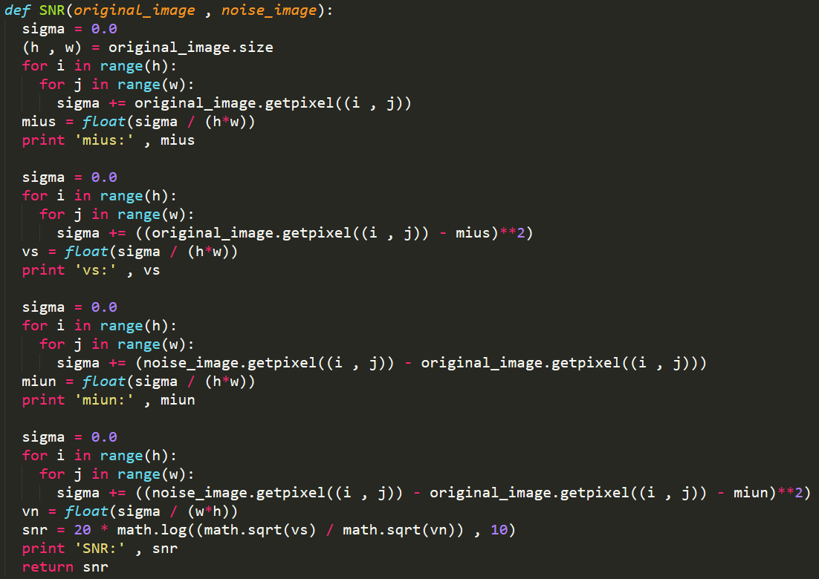

Code of SNR